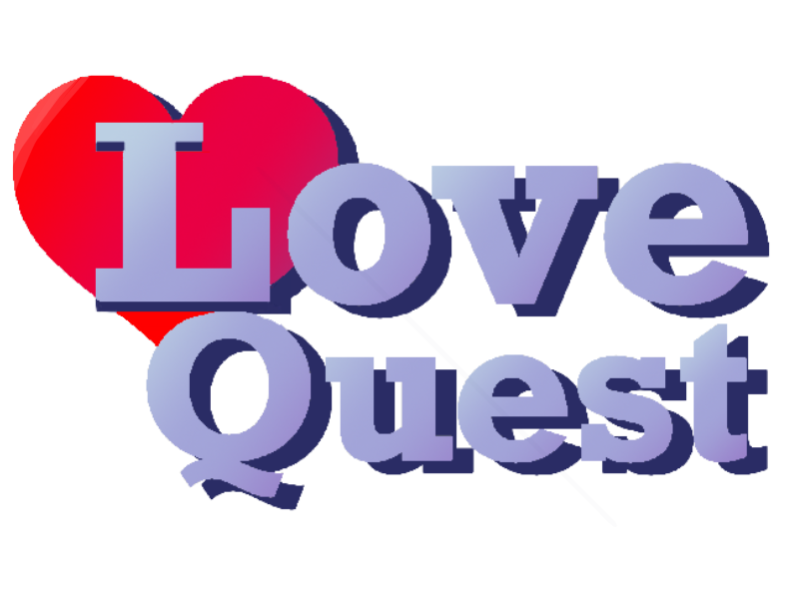

**LOVEQUEST**

**By Team CLIK**

**CS1131 Final Project**

**Cameron Cischke, Liam Allen, Isaak De Ycaza & Kevin Hock**

**December 8th, 2023**

**Version 1.0**

**INTRODUCTION:**

**“Heartquest” is a computer program made by Swedish coding professor Ingemar Ragnemalm in 1992. This program is a recreation of his game, made for the final project of Michigan Tech’s Accelerated intro. to Programming course taught by Leo C. Ureel II and Joe Teahen. The purpose of this game is to provide a nonviolent alternative to the many violent computer games present in the current world. This document provides a summary of our recreation of this game, “LoveQuest”.**

**GAME DESCRIPTION:**

**The Genre of this game is fantasy, and the target audience is younger children, around the kindergarten age. This is a very simple video game meant as an introduction to computers for people who are unfamiliar with them. A core aspect of this game is its themes of nonviolence, making it ideal for a classroom setting. The bright colors and whimsical graphics of this game go to further that goal.**

**The game begins on a starting screen, with buttons to see the credits and to start the game. Once the game is started the player, hearts, and StickyPaper will spawn, and a timer will start. The player controls a butterfly with their mouse, and the butterfly cannot leave the play area. The aim is to collect hearts as quickly as possible by moving your cursor on to them. Collecting a heart will add to your score. Meanwhile, StickyPaper fly around in the wind, and touching them will disable your controls for two seconds. After all hearts have been collected, the game will end. Any time remaining left on the timer will be added as a bonus to your current score. If the timer ends before all hearts are collected, no bonus points will be gained. A leaderboard is taken after the game is completed, and the top 5 scores will be displayed. 3 Difficulties are provided, which provides a challenge to accommodate all skill levels of the player. Additionally, both hardcore (Sticky Papers kill you instantly) and peaceful (no sticky papers will spawn), both affecting the score multipliers.**

**< The Butterfly controlled by the player’s mouse.**

**< One of the Hearts the player must collect.**

**< Touching the StickyPaper will disable your controls for 2 seconds.**

**STORYBOARD**

| **Player starts on the menu screen, with buttons leading to the credits and level select screens.** | **On the credits screen, there’s a button to go back to the main menu.** |
| --- | --- |
|  |  |
| **On the level selection screen, there’s options for easy, medium, and hard. There are also togglable options for peaceful and hardcore modes. When peaceful mode is enabled, there are no sticky papers. When hardcore mode is enabled, sticky paper takes you directly to the game over screen.** |  |

| **In easy mode, there are three hearts and three sticky papers.** | **In medium mode, there are six hearts which are worth fewer points each, six sticky papers, and everything is slightly faster.** | **In hard mode, there are nine hearts which are also worth fewer points, six sticky papers, and everything is even faster.** |
| --- | --- | --- |
|  |  |  |

**After the game is over, you go to the high score page. Enter a 3 character name and hit enter to add your score to the scoreboard, and you’ll be given options to play again or go back to the main menu.**

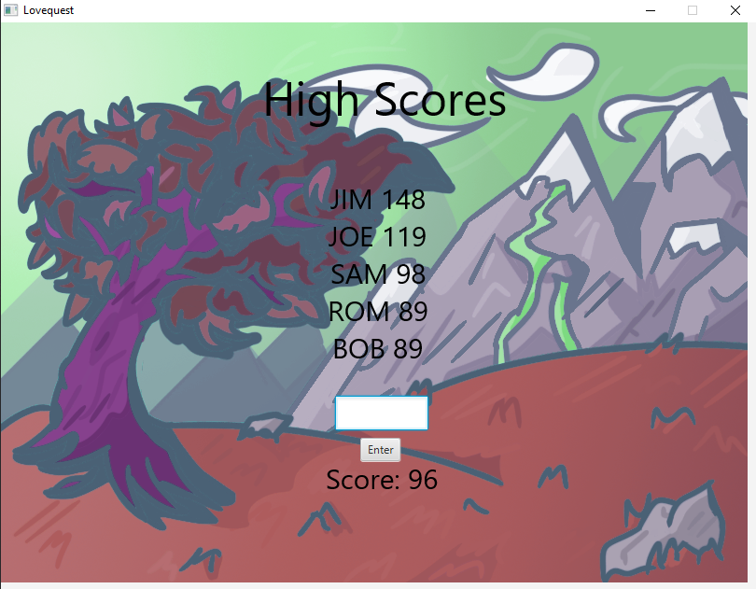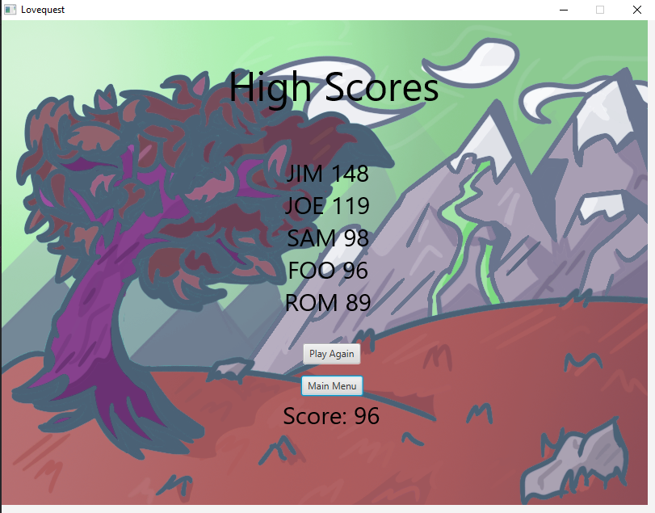

**TECHNICAL SECTION**

**The following is a diagram of how the different methods present in the program interact.**

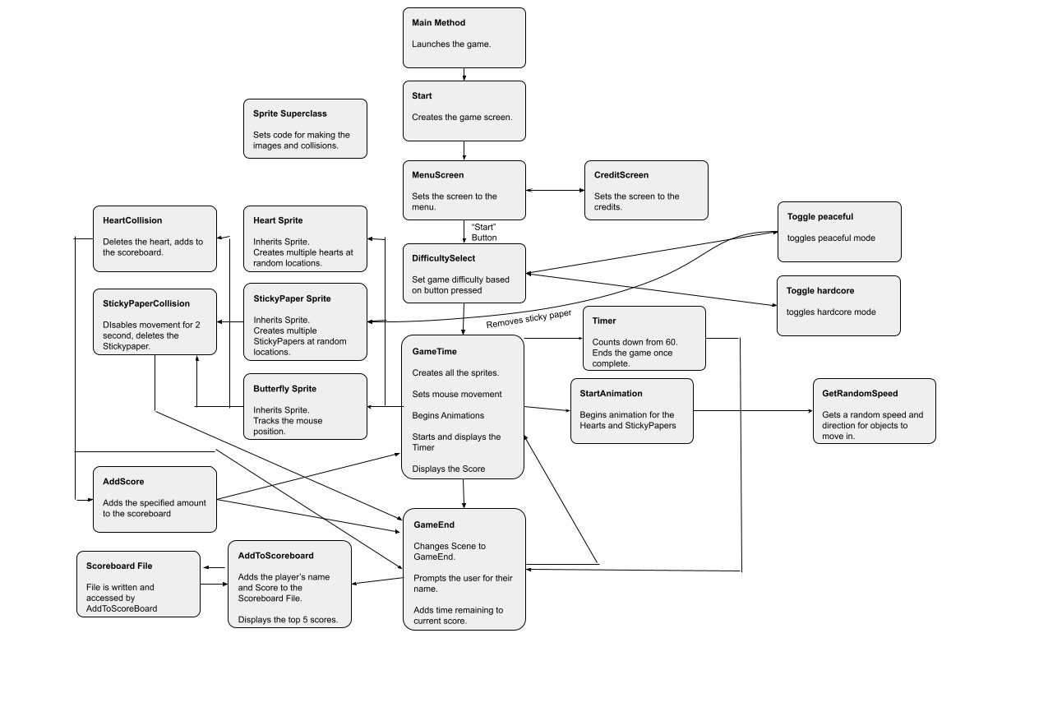

**Scoreboard algorithm:**

**The score board utilizes a text file to store the five highest scores. If a score breaks one of the top five scores, The getFileBoard method makes a singly linked list by adding each score from highest to lowest. Then the updateBoard method will loop through the linked list, once the correct index for the score has been found, the score will be added to the corresponding index. Then it will rewrite the linked list in order until it gets to the fifth element, then it will finish. When the scoreboard is going to be displayed the getBoard method iterates through the text file printing each score.**

**REFERENCES**

* **HeartQuest, Ingemar Ragnemalm.**
* **Introduction to Java Programming and Data Structures, Comprehensive Version, 12th Edition, Y. Daniel Liang.**
* **CS1131 Class Resources**